

UNIVERSITI TEKNOLOGI MALAYSIA

81310, JOHOR BAHRU, JOHOR, MALAYSIA

**SECP1513 (TECHNOLOGY AND INFORMATION SYSTEM)**

**SESSION 2023/2024**

**SECTION 07**

**ASSIGNMENT 1**

**GROUP 7: INNOVATORS**

**TASK: VISIT TO NEW ACADEMIA LEARNING INNOVATION (NALI 2023)**

**TITLE: REPORT ON VISIT NALI 2023**

**DATE OF SUBMISSION:18 NOV 2023**

|  |  |
| --- | --- |
| **NAME** | **MATRIC NUMBER** |
| SITI NURUL AMIRAH BINTI SHEIKH SULAIMAN | A23CS0182 |
| NGEOW ZHI YU | A23CS0255 |
| KHOO ZI LING | A23CS0231 |
| NUR FARHANAH HUSNI BINTI NOR FAIZAL | A23CS0155 |
| ERIKA BINTI HAWAPI | A23CS0076 |
| **LECTURER NAME:** TS. DR. SARINA BINTI SULAIMAN | |

**1.0 INTRODUCTION OF NALI 2023**

NALI 2023, which stands for New Academic Learning Innovation 2023, is a yearly knowledge sharing event that is organized by Universiti Teknologi Malaysia (UTM), through the Center for Advancement in Digital and Flexible Learning (UTM CDex). NALI 2023 is a framework to encourage innovative teaching practices and learning methods in education. NALI 2023 focuses on student-centered and blended learning philosophies, multiple learning methods and materials to achieve entrepreneurial academia. The first NALI event was held in UTM CDex in 2018.

The projects presented in NALI 2023 discussed resilience education for future-oriented quality graduates. These initiatives provide valuable insights into the potential of ICT tools, active learning methods, and collaborative frameworks in promoting resilience and improving the learning experience for students.

|  |  |
| --- | --- |
|  |  |
|  |  |

**2.0 POSTERS WITH EXPLANATIONS**

**POSTER 1: SITI NURUL AMIRAH BINTI SHEIKH SULAIMAN**

The poster shown here presents an introduction to Systematic Problem Solving Process using Computational Thinking in a Technopreneurship Course. As far as we know, computational thinking is a skill utilized in the computer industry and a method of problem-solving that applies computer science concepts. One course that applies computational thinking to the field of technology is Technopreneurship. The word Technopreneurship is the combination of “technology” and “entrepreneurship”. This course teaches us how business-minded individuals use technology to grow and succeed in their careers. Technical proficiency, entrepreneurial skills, and innovative problem-solving abilities are all necessary. Therefore, technopreneurs must be able to identify issues, create and market their innovative products and services.

In the current era, Technopreneurship and Computational Thinking are both crucial. For example, the Computational Thinking ideation process in the business model Canvas. There are four steps to this ideation process which are decomposition, pattern recognition, abstraction, and algorithms. First, is decomposition. We divide the big problems into smaller ones. Then, we want to approach each issue one at a time after first breaking the large problem down into smaller ones. Secondly, we proceed to pattern recognition. We determine which solutions are currently offered on the market. Thirdly, abstraction. We compile every existing solution, evaluate it side by side, and determine what is important to our plan of action and what is not. After that, we simply compile all the useful data and save the rest. Finally, algorithms. We developed a new algorithm to solve that problem, which is our innovative business idea. So, this is how the business ideation method transforms its concept into a model business Canva.

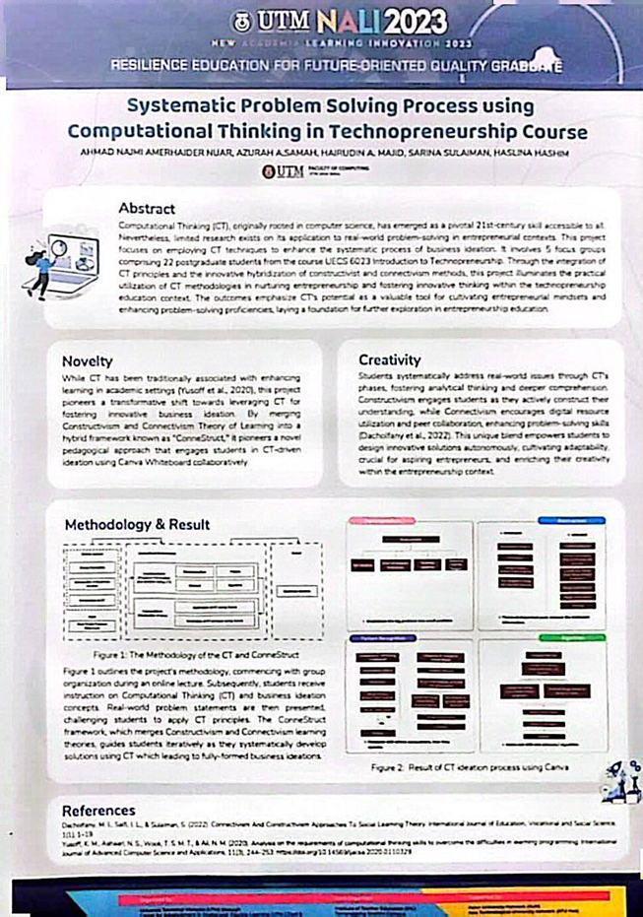

**POSTER 2: NGEOW ZHI YU**

This poster introduces the project BANDURA’S SOCIAL LEARNING THEORY. It is also named Misi Bantu Baca which was initiated during the period July 2021. The primary objective of the “Misi Bantu Baca” project is to enhance the reading literacy skills of children by applying Bandura’s Social Learning Theory in virtual reading class. The theory emphasizes the role of observation, imitation and modeling in learning.

Besides, this project also contributes to students’ resilience during the pandemic where it enables them to take ownership of their education even in the face of uncertainty.

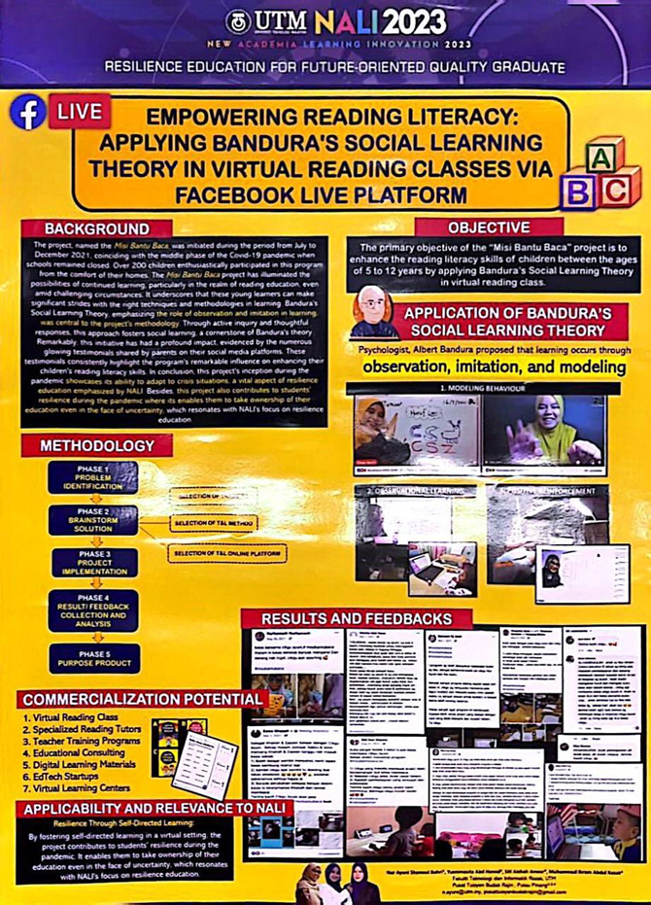

**POSTER 3: KHOO ZI LING**

This poster introduces the project of puzzle games. Puzzle games not only inject enjoyment into the educational process also weld the power to positively impact student performance. Puzzle Games-based learning stands out as a potent resource for active learning, effectively bolstering memory retention.

Furthermore, the Aussie Childcare Network (2022) has outlined specific objectives for puzzle game-based learning, aimed at fostering a child's holistic development. These objectives encompass nurturing visual-perceptual skills, honing attention and concentration, refining hand-eye coordination and fine motor skills, strengthening language skills through verbalizing puzzle-solving processes, and nurturing critical thinking abilities.In light of these considerations, this study is designed to explore the effectiveness of puzzle game-based learning and to gauge student perceptions regarding this active learning tool.

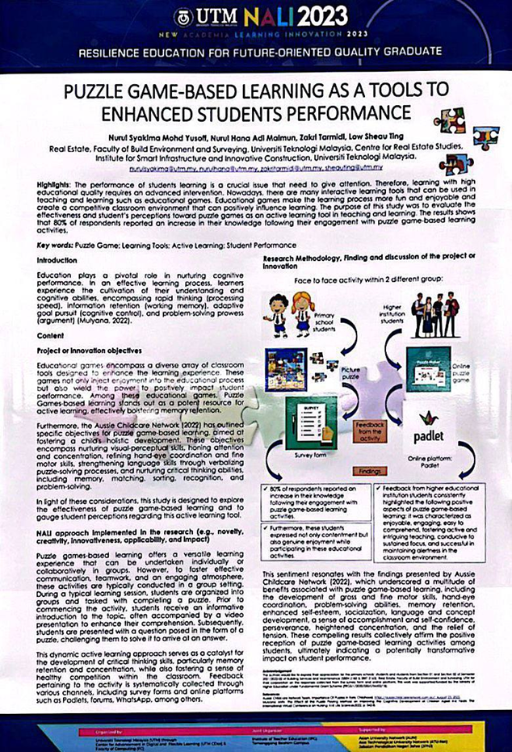

**POSTER 4: NUR FARHANAH HUSNI BINTI NOR FAIZAL**

This poster is about a research project by UTM NALI graduate students that explores the role of ChatGPT in assisting students with multiple-choice questions (MCQs). The objective for this project is to explore and assess the use of OpenAI's ChatGPT as a tool to assist students in developing MCQs. ChatGPT has been chosen because ChatGPT has been recognized for its proficiency in diverse applications, from answering queries to simulating human-like conversations, its potential in education remains largely untapped.

This poster aims to show how ChatGPT can help students create high-quality MCQs that are relevant, accurate, and engaging by methodology that has Table of Specifications Development and experts validation, reliability and item analysis. Students must create the MCQs by referring to the Table of Specifications Development that has been set. Educators can detect whether the student created MCQs just copied and pasted in the assignment if they do not follow the Table of Specification that has been given. ChatGPT is very helpful if students use it ethically and the negative impact of using ChatGPT can be avoided.

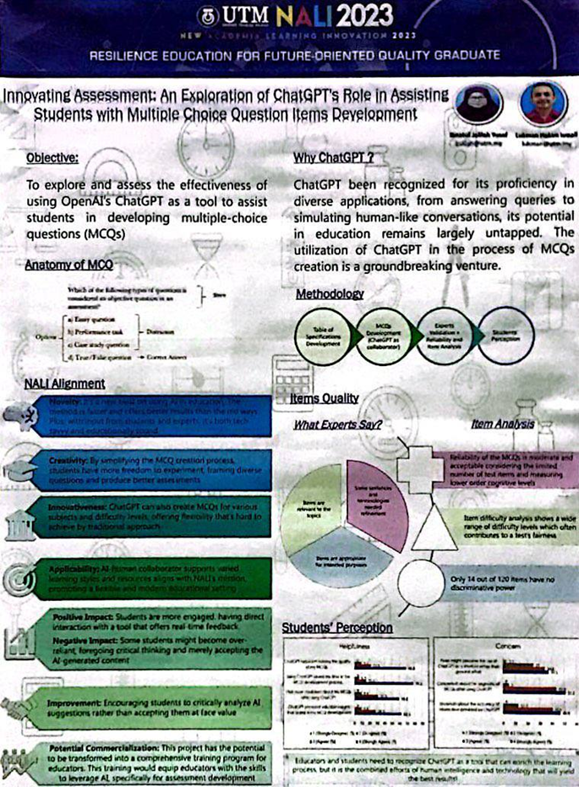

**POSTER 5: ERIKA BINTI HAWAPI**

This poster explains about the Collaborative Assignments and Projects (CAP) framework used in teaching a Real-Time Software Engineering (RTSE) course. The goal of the CAP framework is to help students collaborate in problem solving through practical application of real time concepts and theories. The study aims to improve students’ programming resilience skills by introducing competition-based learning with mobile robots.

It combines theoretical concepts with practical application, promoting collaboration, critical thinking, and programming resilience that are needed to solve real-world software engineering problems.

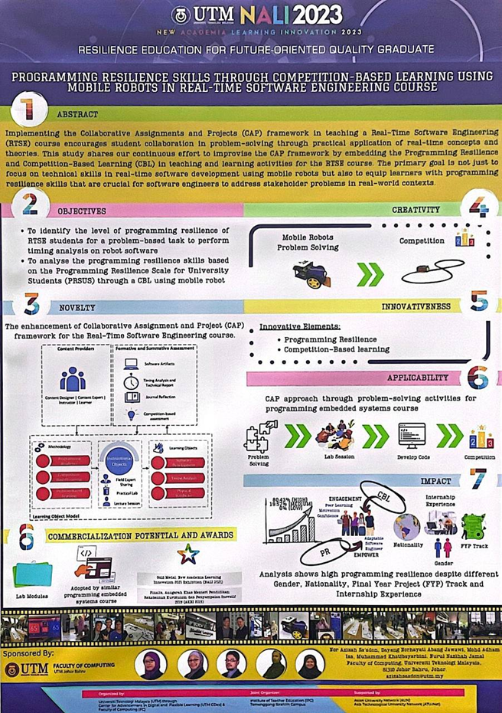

**3.0 RECORDED INTERVIEW**

https://youtu.be/htzw7-aUcjA?feature=shared

**4.0 REFLECTIONS**

**POSTER 1: COMPUTATIONAL THINKING SKILL IN TECHNOPRENEURSHIP COURSE**

**SITI NURUL AMIRAH BINTI SHEIKH SULAIMAN**

My interview focused on the Technopreneurship Course's Systematic Problem-Solving Process utilizing Computational Thinking, and it was based on the NALI program I had enrolled in. I am aware of the applications of computational thinking in the technology sector. With its origins in computer science, computational thinking is a problem-solving methodology that emphasizes decomposition, pattern recognitions, abstraction, algorithms, and systematic problem-solving. For example,Computational Thinking ideation process using Canva.I also study how Canva's ideas becomes a model business via the use of business ideation techniques.   
  
Conclusion, I learned a lot about the information computational thinking skills for computer science students from this program. I want to be able to use this knowledge to my advantage while I study computer science and for the future.

**POSTER 2: BANDURA’S SOCIAL LEARNING**

**NGEOW ZHI YU**

During the interview session, I had known more about the project BANDURA’s SOCIAL LEARNING THEORY. This project is also called, Misi Bantu Baca and mainly focuses on enhancing the reading literacy skills of students by using the skills observation, imitation and modeling.

It is using the platform Facebook live, and children from 5-year-old also can attend the course. It is really a good project as during the period of Covid-19, students cannot attend physical class. Therefore, this project has illuminated the possibilities of continued learning by using the platform Facebook. Thus, this project brings convenience to us as students from everywhere are able to participate in this program.

In conclusion, I consider that students will gain a lot of benefits and will enjoy it while attending this virtual reading class.

**POSTER 3: PUZZLE GAME**

**KHOO ZI LING**

After attending the NALI 2023 program, I learned about the importance of ICT teaching and learning. The interviewing section with Dr Nural Syakima let me know the advantages, objectives , examples and challenges of the puzzles game. The Puzzle game is suitable for all ages of students , it enhances our memory power and makes us better at what we are doing. Besides, I also knew that it was a good idea to use puzzles games in lessons which can lead to brain development.

In conclusion, the NALI 2023 program was interesting and the poster was very creative and easy to understand. Through Dr Nural Syakima’s explanation, I have learned a lot of knowledge! I believe that the children may benefit greatly from this activity and that it is quite fascinating.

**POSTER 4: CHATGPT**

**NUR FARHANAH HUSNI BT NOR FAIZAL**

Based on the poster, as a student I find the topic about an exploration of ChatGPT's role in assisting students with Multiple-Choice Questions(MCQs) item development is very interesting and innovative. It shows how ChatGPT can create MCQs for different subjects and levels of difficulty.I would like to learn more about how ChatGPT works and what are its limitations. First, how does it generate questions that are relevant, accurate, and fair? Second, how does it handle complex or ambiguous topics? Third, how does it deal with plagiarism or cheating? Fourth, how can I evaluate the quality of the questions that ChatGPT produces? All questions have been answered through Mrs. Ibnatul Jalilah's explanation from the interview sessions. I think this project has a lot of potential for commercialization and training. For instance, I would be interested in seeing how ChatGPT can be integrated into online learning platforms or tools that offer interactive quizzes or games for students.

Overall, I think this poster is very inspiring and promising indeed! It shows how ChatGPT can be a powerful ally for students who want to create engaging and effective MCQs. I believe that this knowledge can help me in critical thinking and problem-solving skills as a student and can be very useful as an employee in the future.

**POSTER 5: LEARNING THROUGH ROBOKAR**

**ERIKA BINTI HAWAPI**

After attending NALI 2023, the implementation of the CAP framework in the RTSE course is a commendable approach to promote active learning and enhance students' programming resilience skills. By incorporating competition-based learning using mobile robots, students are encouraged to collaborate and problem-solve in real-time software engineering scenarios. This not only develops their technical skills but also equips them with the necessary resilience to address real-world problems in the field.

I find this approach to teaching and learning in the RTSE course intriguing. It not only focuses on technical skills but also equips learners with programming resilience skills that are crucial for software engineers. It reinforces my belief that hands-on experiences and problem-solving activities are essential for developing programming skills and resilience.

**5.0 CONCLUSION**

NALI 2023 provides insights into various projects and studies related to resilience education and innovative approaches in teaching and learning. The projects discussed include the use of computational thinking in Technopreneurship course in systematic problem solving process, applying Bandura’s social learning theory in virtual reading classes via Facebook live platform, the use of puzzle game-based learning as a tool to enhance student performance. Besides, the project about exploration of ChatGPT as a tool for developing multiple-choice questions in education makes students more engaged by having direct interaction with a tool that offers real-time feedback. ChatGPT is very useful for students and educators if we use it in an ethical way . Last but not least, the implementation of the CAP framework in a Real-Time Software Engineering course.

Overall, the projects presented in NALI 2023 spark excitement and interest in students, making the learning process more enjoyable and engaging. They also contribute to the development of cognitive abilities such as rapid thinking, information retention, adaptive goal pursuit, and problem-solving skills.

**6.0 REFERENCES**

New Academia Learning Innovation 2023. (2023, November). Welcome to UTM New Academia Learning Innovation 2023! Retrieved from https://utmcdex.utm.my/nali2023/

New Academia Learning Innovation 2023. (2023, November). NALI 2023. Facebook. Retrieved from https://www.facebook.com/utm.nali/